**Assignment-1**

1. **Mention the principle that is behind the Agile Manifesto.**

**Ans:** The Twelve Principles are the guiding principles for the methodologies that are included under the title “The Agile Movement.” They describe a culture in which change is welcome, and the customer is the focus of the work.

The twelve principles of agile development include:

1. **Customer satisfaction through early and continuous software delivery:** Customers are happier when they receive working software at regular intervals, rather than waiting extended periods of time between releases.
2. **Accommodate changing requirements throughout the development process:** The ability to avoid delays when a requirement or feature request changes.
3. **Frequent delivery of working software:** Scrum accommodates this principle since the team operates in software sprints or iterations that ensure regular delivery of working software.
4. **Collaboration between the business stakeholders and developers throughout the project:** Better decisions are made when the business and technical team are aligned.
5. **Support, trust, and motivate the people involved:** Motivated teams are more likely to deliver their best work than unhappy teams.
6. **Enable face-to-face interactions:** Communication is more successful when development teams are co-located.
7. **Working software is the primary measure of progress:** Delivering functional software to the customer is the ultimate factor that measures progress.
8. **Agile processes to support a consistent development pace:**Teams establish a repeatable and maintainable speed at which they can deliver working software, and they repeat it with each release.
9. **Attention to technical detail and design enhances agility:** The right skills and good design ensures the team can maintain the pace, constantly improve the product, and sustain change.
10. **Simplicity:** Develop just enough to get the job done for right now.
11. **Self-organizing teams encourage great architectures, requirements, and designs:** Skilled and motivated team members who have decision-making power, take ownership, communicate regularly with other team members, and share ideas that deliver quality products.
12. **Regular reflections on how to become more effective:** Self-improvement, process improvement, advancing skills, and techniques help team members work more efficiently.

The intention of Agile is to align development with business needs, and the success of Agile is apparent. Agile projects are customer focused and encourage customer guidance and participation. As a result, Agile has grown to be an overarching view of software development throughout the software industry and an industry all by itself.

1. **What Is Extreme Programming.**

**Ans:** Extreme Programming (XP) is an agile software development framework that aims to produce higher quality software, and higher quality of life for the development team. XP is the most specific of the agile frameworks regarding appropriate engineering practices for software development.

Characteristics:

* Dynamically changing software a requirements.
* Risks caused by fixed time projects using new technology.
* Small, co-located extended development team.
* The technology you are using allows for automated unit and functional tests.

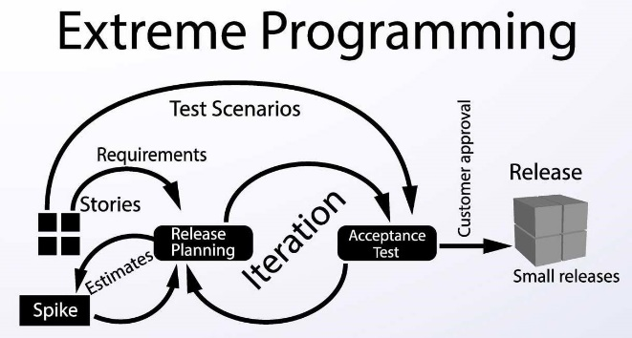

Values:

The XP values: communication, simplicity, feedback, courage, and respect. Let’s look at each one of them in more detail.

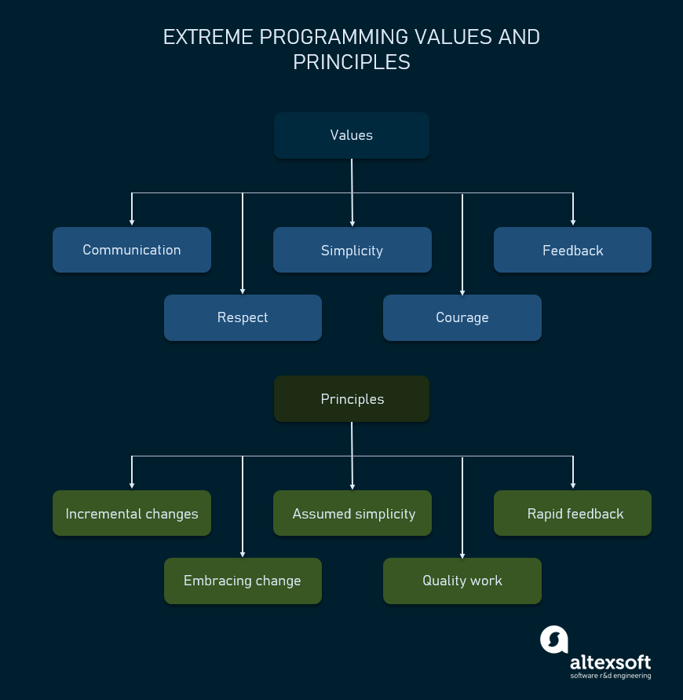

Communication: Lack of communication prevents knowledge from flowing inside a team. Often, when there’s a problem, someone already knows how to solve it. But lack of communication prevents them from learning about the problem or contributing to its solution. So, the problem ends up being solved twice, generating waste.

Simplicity: Simplicity says you always strive to do the simplest thing that works. It’s often misunderstood and taken as *the simplest thing*, period, ignoring the “that works” part.

Feedback: Feedback in more traditional, waterfall-like software development methodologies often is “too little, too late”.

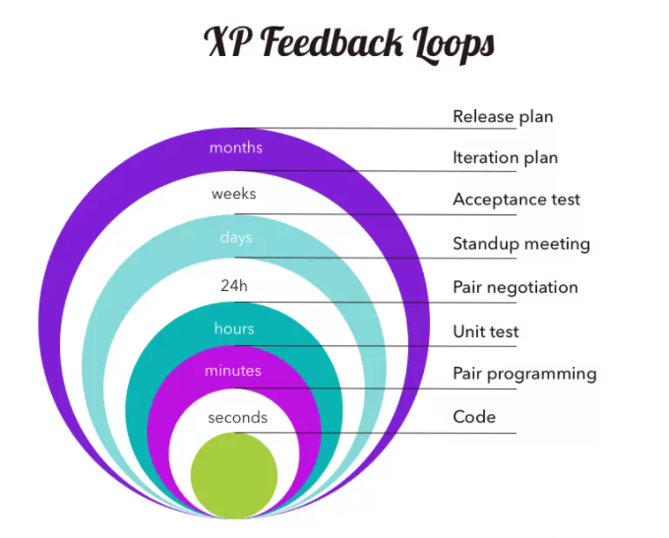

Courage: Kent Beck defines courage as “effective action in the face of fear.” As a software engineer, you have plenty to be afraid of and therefore plenty of opportunities to show courage.

Respect: A fundamental premise of XP is that everyone cares about their work. No amount of technical excellence can save a project if there’s no care and respect.

Principles:

Principles provide more specific guidance than values. They’re guidelines that illuminate the values and make them more explicit and less ambiguous.

Humanity: Humans create software for humans, a fact that’s often overlooked. But taking human basic needs, strengths, and weaknesses into account creates products humans *want* to use. And a work environment that gives you the opportunity for accomplishment and growth, the feeling of belonging, and basic safety, is a place where you more easily take others’ needs into account.

Economics: In XP, teams heed the economic realities of software development all the time, they constantly assess the economic risks and needs of the project.

.

Mutual Benefit: Following XP, you avoid solutions that benefit one party to the detriment of another. For instance, extensive specifications might help someone else understand it, but it takes you away from implementing it, and it delays it for your users.

Self-similarity: If a given solution works at a level, it might also work at a higher or lower level. For instance, obtaining early and constant feedback is at play at various levels in XP.

* at the developer level, programmers receive feedback from their work using the test-first approach;
* at the team level, the continuous integration pipeline integrates, builds, and tests the code several times a day;
* at the organization level, the weekly and quarterly cycles allow teams to get feedback and improve their work as needed.

Improvement: According to the principle of improvement, teams don’t strive for perfection in an initial implementation but for a good enough one, and to then learn and improve it continuously with feedback from real users.

Diversity: You and your coworkers benefit from a diversity of perspectives, skills, and attitudes. Such diversity often leads to conflict, but that’s okay.

Reflection: Great teams reflect on their work and analyze how to be better. XP offers plenty of opportunities for that. Not just in its weekly and quarterly cycles, but in every practice it promotes.

Flow: Traditional software development methodologies have discrete phases, which last for a long time and have few feedback and course correction opportunities. Instead, software development in XP occurs in activities that happen all of the time, in a consistent “flow” of value.

Opportunity: Problems are inevitable in software development. However, every problem is an opportunity for improvement. Learn to look at them that way and you’re far more likely to come up with creative, goal-oriented solutions that also serve to prevent them from happening again.

Redundancy: The redundancy principle says that if a given problem is critical, you must employ many tactics to counter it.

Failure: Failure isn’t waste when it results in knowledge. Acting and quickly learning what doesn’t work is way more productive than inaction caused by indecision in choosing between many options.

Quality: Often people think there’s a dilemma between quality and speed. It’s the opposite: pushing for quality improvements is what makes you go faster.

Baby Steps: Big changes are risky. XP mitigates that risk by doing changes in tiny steps, at all levels.

Accepted Responsibility: In XP, responsibility should be accepted, never assigned.

1. **What is Extreme Programming Practices.**

**Ans:** There are four basic activities in Extreme Programming. They are:

* Coding
* Testing
* Listening
* Designing

These four basic activities need to be structured in the light of the Extreme Programming principles. To accomplish this, the Extreme Programming practices are defined.

These 12 Extreme Programming practices achieve the Extreme Programming objective and wherever one of the practices is weak, the strengths of the other practices will make up for it.

Kent Beck, the author of ‘Extreme Programming Explained’ defined 12 Extreme Programming practices as follows −

* The Planning Game
* Short Releases
* Metaphor
* Simple Design
* Testing
* Refactoring
* Pair Programming
* Collective Ownership
* Continuous Integration
* 40 hour Week
* On-site Customer
* Coding Standards

Four Areas of Extreme Programming

The Extreme Programming practices can be grouped into four areas −

* Rapid, Fine Feedback −
  + Testing
  + On-site customer
  + Pair programming
* Continuous Process −
  + Continuous Integration
  + Refactoring
  + Short Releases
* Shared Understanding −
  + The Planning Game
  + Simple Design
  + Metaphor
  + Collective Ownership
  + Coding Standards
* Developer Welfare −
  + Forty-Hour Week

The following diagram shows how Extreme Programming is woven around the Extreme Programming practices −

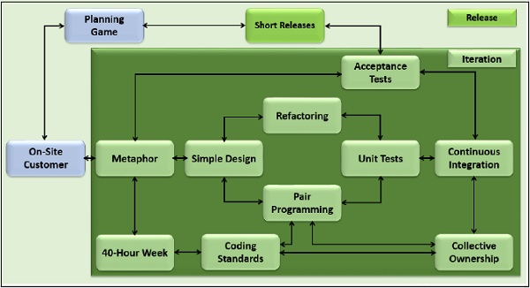

1. **What is SCRUM.**

**Ans:** Scrum is a framework within which people can address complex adaptive problems, while productively and creatively delivering products of the highest possible value.

Idea first appeared in a business journal in 1986 (applied to product development management).

* Used in software development and presented in 1995 paper.
* Term is based on rugby term
* Small cross-functional teams

1. **Explain the SCRUM Practices.**

**Ans:** There are mainly 4 types of SCRUM Practices, which are given below:

Product and release backlog:

* A list of the features to be implemented in the project (subdivided to next release), ordered by priority
* Can adjust over time as needed, based on feedback
* A product manager is responsible for maintaining

Burn-down chart:

* Make best estimate of time to complete what is currently in the backlog
* Plot the time on a chart
* By studying chart, understand how team functions
* Ensure burndown to 0 at completion date
  + By adjusting what’s in the backlog
  + By adjusting the completion date

The sprint Chart:

* The sprint is a 1 month period after which some product is delivered
* Features are assigned from the product backlog to a sprint backlog
  + Features divided into smaller tasks for sprint backlog
  + Feature list is fixed for sprint
* Planning meeting
  + Tasks can be assigned to team members
  + Team members have individual estimates of time taken per item
* During sprint, work through features, and keep a burn-down chart for the sprint
* New functionality is produced by the end of the sprint
* After sprint, a review meeting is held to evaluate the sprint.

Scrum meeting:

* 15 minute daily meeting
* All team members show up
* Quickly mention what they did since last Scrum, any obstacles encountered, and what they will do next
* Some team member volunteers or is appointed to be the Scrum Master - in charge of Scrum meeting, and responsible for seeing that issues raised get addressed
* Customers, management encouraged to observe

1. **Explain the Sprint in SCRUM Practices.**

**Ans:** The Chart gives a brief idea about the Sprint Chart:

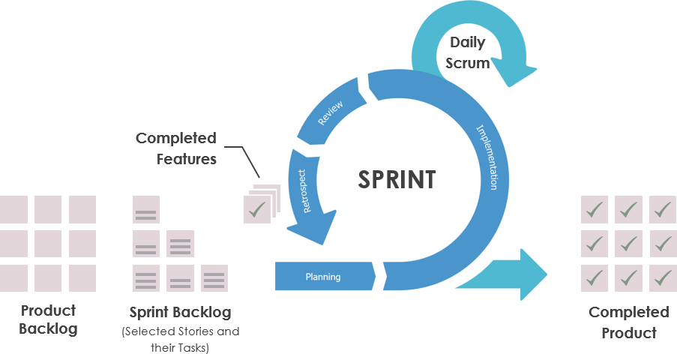

Sprints are the heartbeat of Scrum, where ideas are turned into value.

They are fixed length events of one month or less to create consistency. A new Sprint starts immediately after the conclusion of the previous Sprint.

All the work necessary to achieve the Product Goal, including Sprint Planning, Daily Scrums, Sprint Review, and Sprint Retrospective, happen within Sprints.

During the Sprint:

* No changes are made that would endanger the Sprint Goal
* Quality does not decrease
* The Product Backlog is refined as needed
* Scope may be clarified and renegotiated with the Product Owner as more is learned.

Sprints enable predictability by ensuring inspection and adaptation of progress toward a Product Goal at least every calendar month. When a Sprint’s horizon is too long the Sprint Goal may become invalid, complexity may rise, and risk may increase. Shorter Sprints can be employed to generate more learning cycles and limit risk of cost and effort to a smaller time frame. Each Sprint may be considered a short project.

Various practices exist to forecast progress, like burn-downs, burn-ups, or cumulative flows. While proven useful, these do not replace the importance of empiricism. In complex environments, what will happen is unknown. Only what has already happened may be used for forward-looking decision making.

1. **What is Spiking, Splitting, and Velocity in Planning?**

**Ans:** The definition of all three planning phases are given below:

Splitting:

For example, “Users can securely transfer money into, out of, and between their accounts.” - big story. Estimating will be hard and probably inaccurate. Further Splitting above story in

* Users can log in.
* Users can log out.
* Users can deposit money into their account.
* Users can withdraw money from their account.
* Users can transfer money from their account to another account.

Velocity:

* If we have an accurate velocity, we can multiply the estimate of any story by the velocity to get the actual time
* For example, our velocity is “2 days per story point,” and we have a story with a relative estimate of four points, then the story should take eight days to implement.
* As the project proceeds, the measure of velocity will become ever more accurate

Spiking:

* Often, it is sufficient to spend a few days prototyping a story or two to get an idea of the team’s velocity. Such a prototype session is called a spike.

1. **Explain Release Planning, Iteration Planning, Task planning.**

**Ans:**

Release Planning:

* The developers and customers agree on a date for the first release of the project. This is usually a matter of 2–4 months in the future. The customers pick the stories they want implemented within that release and the rough order in which they want them implemented.
* The release plan can be adjusted as velocity becomes more accurate.

Iteration Planning:

* typically, two weeks long
* the customers choose the stories that they want implemented in the first iteration.
* The order of the stories within the iteration is a technical decision that makes the most technical sense.
* The customers cannot change the stories in the iteration once the iteration has begun - Reordering is possible
* The iteration ends on the specified date, even if all the stories aren’t done.
* If the team got 31 story points done last iteration, then they should plan to get 31 story points done in the next. Their velocity is 31 points per iteration.
* If the team gains in expertise and skill, the velocity will rise commensurately. If someone is lost from the team, the velocity will fall. If an architecture evolves that facilitates development, the velocity will rise.

Task Planning:

* The developers break the stories down into development tasks. A task is something that one developer can implement in 4–16 hours. The stories are analyzed, with the customers’ help, and the tasks are enumerated as completely as possible.
* A list of the tasks is created on a flip chart, whiteboard, or some other convenient medium. Then, one by one, the developers sign up for the tasks they want to implement.
* Developers, Database Guys, GUI guys (whole Project team) may sign up for respective kind of task.
* Task selection continues until either all tasks are assigned

1. **What is Halfway Point in Planning?**

**Ans:**

The Halfway Point:

* Halfway through the iteration, the team holds a meeting.
* At this point, half of the stories scheduled for the iteration should be complete. If aren’t complete, then the team tries to reapportion tasks and responsibilities to ensure that all the stories will be complete by the end of the iteration

For Example,

* + Suppose the customers selected 8 Stories
  + 8 Stories Totally 24 story points 42 Tasks
  + Halfway point 12 story points 21 Tasks should be completed
* At the halfway point, we want to see completed stories that represent half the story points for the iteration.

1. **Explain Iterating in brief.**

**Ans:**

Iterating:

* Every two weeks, the current iteration ends and the next begins.
* At the end of each iteration, the running executable is demonstrated to the customers.
* The customers are asked to evaluate the look, feel, and performance of the project.
* The customers can measure velocity. They can predict how fast the team is going, and they can schedule high- priority stories early.

1. **Explain Test Driven Development in brief.**

**Ans:**

* What if we designed our tests before we designed our programs?
* What if we refused to implement a function in our programs until there was a test that failed because that function wasn’t present?
* What if we refused to add even a single line of code to our programs unless there were a test that was failing because of its absence?
* What if we incrementally added functionality to our programs by first writing failing tests that asserted the existence of that functionality, and then made the test pass?
* What effect would this have on the design of the software we were writing? What benefits would we derive from the existence of such a comprehensive bevy of tests?

We can add functions to the program, or change the structure of the program, without fear that we will break something important in the process.

* we are immediately concerned with the interface of the program as well as its function. By writing the test first, we design the software to be conveniently callable.
* we are immediately concerned with the interface of the program as well as its function. By writing the test first, we design the software to be conveniently callable.
* The act of writing tests first forces us to decouple the software!

An Example of Test-First Design:

* I trusted that I could make the test pass by writing the code that conformed to the structure implied by the test. This is called intentional programming.
* The point is that the test illuminated a central design issue at a very early stage. The act of writing tests first is an act of discerning between design decisions.
* The test acts as a compile able and executable document that describes the program

1. **Explain Test Isolation in Test Driven Development with appropriate diagram.**

**Ans:** The act of writing tests before production code often exposes areas in the software that ought to be decoupled.

For example, Let’s see a simple UML diagram of a payroll application.



* This diagram is just sitting on a whiteboard after a quick design session and that we haven’t written any of this code yet.
* There are a number of problem
* First, what database do we use? Payroll needs to read from some kind of database. What data do we load into it?
* Second, how do we verify that the appropriate check got printed? We can’t write an automated test that looks on the printer for a check and verifies the amount on it’s associated with writing these tests.
* It creates the appropriate mock objects, passes them to the Payroll object, tells the Payroll object to pay all the employees, and then asks the mock objects to verify that all the checks were written correctly and that all the payments were posted correctly.



1. **Explain Acceptance Test with example.**

**Ans:**

* Unit tests are necessary but insufficient as verification tools.
* Unit tests verify that the small elements of the system work as they are expected to, but they do not verify that the system works properly as a whole.
* Unit tests are white-box tests that verify the individual mechanisms of the system.
* Acceptance tests are black-box tests that verify that the customer requirements are being met.
* Acceptance tests are written by folks who do not know the internal mechanisms of the system.
* They may be written directly by the customer or by some technical people attached to the customer, possibly QA. Acceptance tests are programs and are therefore executable.
* Acceptance tests are the ultimate documentation of a feature.
* Creating an acceptance testing framework may seem a daunting task.
  + Example of Acceptance Testing
  + Consider, the payroll application
  + we must be able to add and delete employees to and from the database. We must also be able to create paychecks for the employees currently in the database. Fortunately, we only have to deal with salaried employees. The other kinds of employees have been held back until a later iteration.
  + it makes sense that the acceptance tests should be written in simple text files.

AddEmp 1429 “Robert Martin” 3215.88 Payday

Verify Paycheck EmpId 1429 GrossPay 3215.88

* We need to find some common form for those transactions so that the amount of specialized code is kept to a minimum.
* One solution would be to feed the transactions into the payroll application in XML

<AddEmp PayType=Salaried>

<EmpId>1429</EmpId>

<Name>Robert Martin</Name>

<Salary>3215.88</Salary>

</AddEmp>

* We can have the payroll application produce its paychecks in XML

<Paycheck>

<EmpId>1429</EmpId>

<Name>Robert Martin</Name>

<GrossPay>3215.88</GrossPay>

</Paycheck>

1. **What is Refactoring and when should it be used?**

**Ans:** Process of changing a computer program’s source code without modifying its external functional behavior.

To improve some of the nonfunctional attributes: code readability reduced complexity to improve maintainability better design

* Extensibility

“By continuously improving the design of code, we make it easier and easier to work with. This is in sharp contrast to what typically happens: little refactoring and a great deal of attention paid to expediently adding new feature. If you get into the hygienic habit of refactoring continuously, you’ll find that it is easier to extend and maintain code.”

Refactoring – When do I use?

* Bad smells!
* A structure in the code suggests, and sometimes even scream for, opportunities for refactoring
* This humorous advice relies on the experience of programmers and on the clarity of code
* Indications to possible bad smells:
* Duplicated code shares one same method
* Long method extracts one or more smaller methods
* Large class divides in more cohesive classes
* Long parameter list encapsulates them
* There is a almost a hundred catalogued refactoring’s
* each one has a name, a motivation, and a mechanics
* They are usually organized into the following groups:
  + Composing Methods (e.g., Extract Method)
  + Moving Features Between Objects (e.g., Move Method)
  + Organizing Data (e.g., Encapsulate Field)
  + Simplifying Conditional Expressions (e.g., Consolidate Conditional Expression)
  + Making Method Calls Simpler (e.g., Rename Method)
  + Dealing with Generalization (e.g., Pull Up Method)
  + Big Refactoring (e.g., Extract Hierarchy)

1. **Explain Extract method with appropriate example in Refactoring.**

**Ans:** You have a code fragment that can be grouped together then turn the fragment into a method whose name explains the purpose of the method.

The Example below gives a brief idea about the Extract method.

* It is one of the most common refactoring’s
* Long methods or look at code that needs a comment to understand its purpose
* So, I turn that fragment of code into its own method.
* Reasons to do that:
  + Increases the chances that other methods can use a method when the method is fine-grained
  + Allows the higher-level methods to read more like a series of comments
  + Overriding also is easier

1. **Explain Pull up method with appropriate example in Refactoring.**

**Ans:** You have methods with identical results on subclasses then move them to the superclass.

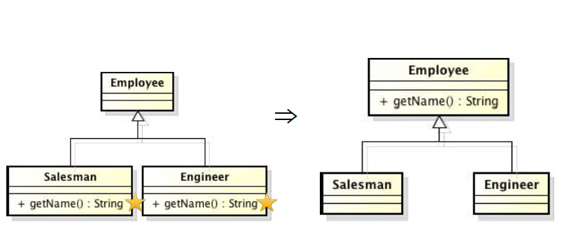

* Eliminating duplicate behavior is important
  + if not, the risk that a change to one not be made to other
* The easiest case: methods have the same body
  + of course, it is not always obvious as that. So, look for the differences and test for safety
* Special case: you have a subclass method that overrides a superclass method yet does the same thing
* The most awkward case: the method may refer to features that are on the subclass but not on the superclass
  + possible solutions: generalize methods, create abstract method on superclass, change a method’s signature.

1. **Explain Move method with appropriate example in Refactoring.**

**Ans:** A method is, or will be, using or used by more features of another class than the class on which it is defined as Feature Envy.

Create a new method with similar body in the class it uses most. Either turn the old method into a simple delegation, or remove it.

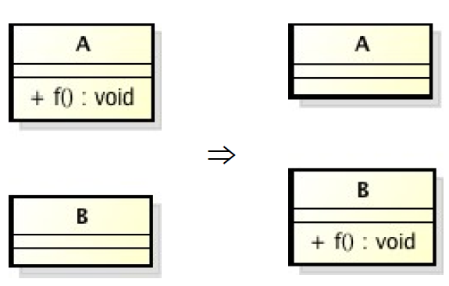

* Moving methods is the bread and butter of refactoring
  + classes with too much behavior
  + classes are collaborating too much (too highly coupled)
* By moving methods around:
  + make classes simpler
  + high cohesion (classes end up being a more crisp implementation of a set of responsibilities).

1. **Explain Extract Super Class method with appropriate example in Refactoring.**

**Ans:** You have two classes with similar features then create a superclass and move the common features to the superclass.

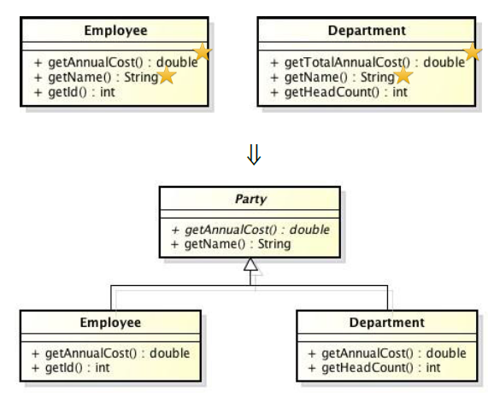

* Duplicate code is one of the principal bad things in systems
* Duplicate code:
  + two classes that do similar things in the same way or two classes that do similar things in different ways
* A well-known solution: inheritance (everything)
  + However, you often do not notice the commonalities until you have created some classes
  + In this case, you need to create the inheritance structure later.

**Assignment - 2**

1. **What is Agile Design?**

**Ans:** If agility is about building software in tiny increments, how can you ever design the software?

* How can you take the time to ensure that the software has a good structure that is flexible, maintainable, and reusable?
* If you build in tiny increments, aren’t you really setting the stage for lots of scrap and rework in the name of refactoring?
* Aren’t you going to miss the big picture?
* The big picture evolves along with the software. With each iteration, the team improves the design of the system so that it is as good as it can be for the system as it is now.

1. **Mention symptoms of poor design in brief.**

**Ans:** Symptoms of Poor Design:

* **Rigidity**: The design is hard to change.
* **Fragility**: The design is easy to break
* **Immobility**: The design is hard to reuse.
* **Viscosity**: It is hard to do the right thing.
* **Needless Complexity**: Overdesign.
* **Needless Repetition**: Mouse abuse.
* **Opacity**: Disorganized expression.

1. **Mention the odors of Rotting Software’s.**

**Ans:** Design Smells -The Odors of Rotting Software:

* **Rigidity**: The system is hard to change because every change force many other changes to other parts of the system.
* **Fragility**: Changes cause the system to break in places that have no conceptual relationship to the part that was changed.
* **Immobility**: It is hard to disentangle the system into components that can be reused in other systems.
* **Viscosity**: Doing things right is harder than doing things wrong.
* **Needless Complexity**: The design contains infrastructure that adds no direct benefit.
* **Needless Repetition**: The design contains repeating structures that could be unified under a single abstraction.
* **Opacity**: It is hard to read and understand. It does not express its intent well

1. **Explain mention below principle with diagrams and appropriate example.**

**Ans:** Object-oriented design that help developers eliminate design smells and build the best designs for the current set of features.

* The principles are as follows:

1. SRP: The Single Responsibility Principle
2. OCP: The Open-Closed Principle.
3. LSP: The Liskov Substitution Principle.
4. ISP: The Interface Segregation Principle.
5. DIP: The Dependency Inversion Principle.

**SRP: The Single Responsibility Principle:**

Each class should only be responsible for a single cohesive responsibility. Each responsibility is an axis of change. When the demand changes, the change will be reflected as the change in the responsibility of the class. A class should have only one reason for its change. If a class assumes more than one responsibility, then there will be multiple reasons for its change, which is equivalent to coupling these responsibilities together. Designs that violate SRP can usually be reconstructed using facade mode or agent mode to separate business responsibilities.



More than one responsibility:

* Two different applications use the Rectangle class.
  + One application does computational geometry. It uses Rectangle to help it with the mathematics of geometric shapes. It never draws the rectangle on the screen.
  + The other application is graphical in nature. It may also do some computational geometry, but it definitely draws the rectangle on the screen
* A better design is to separate the two responsibilities into two completely different classes as shown above.
* This design moves the computational portions of Rectangle into the Geometric Rectangle class.
* Now changes made to the way rectangles are rendered cannot affect the Computational Geometry Application.



Responsibility:

We define a responsibility to be “a reason for change.” If you can think of more than one motive for changing a class, then that class has more than one responsibility.

interface Modem {

public void dial(String pno); public void hangup();

public void send(char c); public char recv();

}

**OCP: The Open–Closed Principle:**

* Software entities (classes, packages, modules, etc.) should be extensible, but unmodifiable, that is, they are open for expansion and closed for modification. When expanding the behavior of an entity, there is no need to change the source code or binary code, that is The Open-Closed Principle. The key to the principle of opening and closing is abstract design. It is impossible for complete OCP. The most likely and most frequent changes should be abstracted. Following the principle of opening and closing, rejecting immature abstraction is as important as abstraction itself.
* A module will be said to be open if it is still available for extension. For example, it should be possible to add fields to the data structures it contains, or new elements to the set of functions it performs.
* A module will be said to be closed if it is available for use by other modules. This assumes that the module has been given a well-defined, stable description (the interface in the sense of information hiding)
* But the real challenge is anticipation, anticipating is hard In real world, when you anticipate the risk is high that:
  + We do anticipate variations that won’t vary.: Always implement things when you actually need them, never when you just foresee that you need them. Developing and maintaining an abstraction has a cost and if we won’t need it this cost is negative.
  + The risk is also high that we don’t anticipate the variation that will really be needed. But once the need for variation becomes real this is your developer responsibility to refactor and create the right abstractions and the right stable code that will act upon these abstractions

**LSP: The Liskov Substitution Principle:**

* Subtypes must be able to completely replace their base types. The types satisfying the Liskov principle satisfy the following properties: if there is an object O2 of type T for every object O1 of type S, so that in all programs written for T, after replacing O2 with O1, the behavioral function of the program Change, then S is a subtype of T. The IS-A relationship in OOD is in terms of the behavior mode. The behavior mode can be reasonably assumed and is dependent on the client program. The effectiveness of the model can only be reflected through its client program. Some inheritance designs that violate the LSP can use the method of extracting common parts instead of inheritance.
* There are other, far more subtle, ways of violating the LSP. Consider an application which uses the Rectangle class
* Imagine that this application works well and is installed in many sites. As is the case with all successful software, its users demand changes from time to time. One day, the users demand the ability to manipulate squares in addition to rectangles.
* It is often said that inheritance is the IS-A relationship. In other words, if a new kind of object can be said to fulfill the IS-A relationship with an old kind of object, then the class of the new object should be derived from the class of the old object.
* For all normal intents and purposes, a square is a rectangle. Thus, it is logical to view the Square class as being derived from the Rectangle class.
* This use of the I -A relationship is sometimes thought to be one of the fundamental techniques of object-oriented analysis: A square is a rectangle, and so the Square class should be derived from the Rectangle class.

**ISP: Interface Segregation Principle:**

* Customers should not be forced to rely on the methods they do not use.
* Fat interfaces can cause abnormal and harmful coupling between their client programs. When a client program requires a change to the fat interface, it will affect other client programs. Therefore, client programs should only depend on what they actually call The method can achieve this goal by separating the fat interface into multiple specific client program interfaces.
* Each client-specific interface only declares the methods that its client program needs to call, and the implementation class implements all client- specific interfaces, releasing these coupling relationships so that the client programs do not depend on each other.
* Common methods of separating interfaces include the use of delegate separation and the use of multiple inheritance separation. The key to separating interfaces is to group the customers of the interface.
* Consider a security system. In this system, there are Door objects that can be locked and unlocked, and which know whether they are open or closed.
* This class is abstract so that clients can use objects that conform to the Door interface, without having to depend on particular implementations of Door.
* Let’s consider TimedDoor, needs to sound an alarm when the door has been left open for too long. In order to do this, the TimedDoor object communicates with another object called a Timer.
* When an object wishes to be informed about a time-out, it calls the Register function of the Timer. The arguments of this function are the time of the time-out, and a pointer to a TimerClient object whose TimeOut function will be called when the time-out expires.
* We force Door, and therefore TimedDoor, to inherit from TimerClient. This ensures that TimerClient can register itself with the Timer and receive the TimeOut message.



* Chief among these is that the Door class now depends on TimerClient. Not all varieties of Door need timing. Indeed, the original Door abstraction had nothing whatever to do with timing. If timing-free derivatives of Door are created, those derivatives will have to provide degenerate implementations for the TimeOut method-a potential violation of the LSP.
* Moreover, the applications that use those derivatives will have to import the definition of the TimerClient class, even though it is not used. That smells of Needless Complexity and Needless Redundancy

**DIP: The Dependency Inversion Principle:**

* High-level modules should not depend on low- level modules, both should rely on abstraction;
* Each higher level declares an abstract interface for the services it needs, the lower level implements these abstract interfaces, and each high-level class uses the next layer through this abstract interface, so that the high level does not depend on the lower level, but the lower level instead Depends on the abstract service interface declared by high-level.

Example:

* The high-level Policy layer uses a lower-level Mechanism layer, which in turn uses a detailed- level Utility layer. While this may look appropriate, it has the insidious characteristic that the Policy layer is sensitive to changes all the way down in the Utility layer.
* Dependency is transitive.
* The Policy layer depends on something that depends on the Utility layer; thus, the Policy layer transitively depends on the Utility layer. This is very unfortunate.
* Each of the upper-level layers declares an abstract interface for the services that it needs.
* The lower-level layers are then realized from these abstract interfaces
* This is sometimes known as the Hollywood principle: “Don’t call us, we’ll call you.” The lower-level modules provide the implementation for interfaces that are declared within, and called by, the upper-level modules.



* Abstraction should not depend on details, details should depend on abstractions;
* All the dependencies in the program should end in an abstract class or interface, that is:
  + No variable should hold a pointer or reference to a specific class;
  + No class should be derived from a concrete class;
  + No method should override the methods already implemented in any of its base classes;
* If a concrete class is unlikely to change, and other similar derived classes will not be created, then relying on it will not cause damage.

For example: java language, String.

* Consider the case of the Button object and the Lamp object
* Figure shows a naive design. The Button object receives Poll messages, determines if the button has been pressed, and then simply sends the TurnOn or TurnOff message to the Lamp.



**Assignment - 3**

**1. What is User Experience?**

* User experience (UX) design is the **process design teams use to create products** that provide meaningful and relevant experiences to users.
* This involves the design of the entire process of acquiring and integrating the product, including aspects of branding, design, usability and function.
* The **user experience** (**UX** or **UE**) is how a user interacts with and experiences a product, system or service.
* It includes a person's perceptions of utility, ease of use, and efficiency. Improving user experience is important to most companies, designers, and creators when creating and refining products because negative user experience can diminish the use of the product and, therefore, any desired positive impacts; conversely, designing toward profitability often conflicts with ethical user experience objectives and even causes harm. User experience is subjective.

**2. Explain UX Design Life cycle process.**

* It is a structured framework consisting of a series of stages and corresponding that characterize the course of evolution of, in this context, the full evolution of an interaction design or a complete system or product.

❑ UX Lifecycle Activities

❑ Understand Needs (of users).

❑ Design Solutions.

❑ Prototype Candidates (for promising designs).

❑ Evaluate UX

Prototype Candidates

Realize design alternatives

Design solution

Create design concepts

Evaluate UX

Verify and refine designs

Understand needs

Understand user work and need

**3. Mention and explain the fundamental UX Lifecycle Activities with appropriate Diagram.**

In this topic, we look more in depth at the individual UX design lifecycle activities and sub activities:

**The four basic UX lifecycle activities:**

* **Understand Needs**, to understand users, work practice, usage, the subject-matter domain, and, ultimately, needs for the design.
* **Design Solutions**, to create designs as solutions.
* **Prototype Candidates** (of promising solutions) to realize and envision promising design candidates.
* **Evaluate UX**, to verify and refine designs with respect to the user experience they afford.

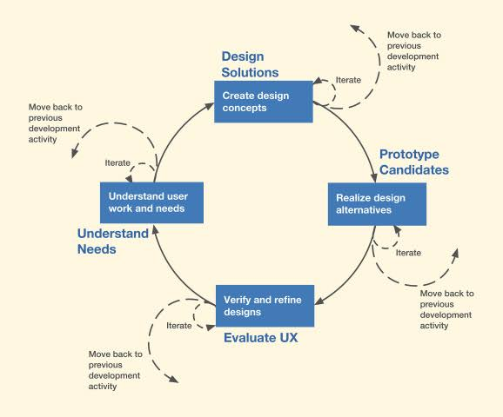

**The Understand Needs:**

* The Understand Needs lifecycle activity is used to understand the business domain, users, work practice, usage, and the overall subject-matter domain. The most popular method is some variation of usage research and the most rigorous version includes these sub activities
* Data elicitation: Interview and observe users at work and gather data about work practice, users, usage, and needs.
* Data analysis: Distill and organize usage research data.
* Data modeling: Create representations of user characteristics, information flow, tasks, and work environments (for collaboration, sharing, archival, rehearsal, immersion).
* Requirements extraction: Codify needs and requirements ese sub activities,

**The Design Solutions:**

Design Solutions is perhaps the most important lifecycle activity and the one with the broadest

preview. Typical sub activities of this activity change dramatically over time as the project and the product evolve and mature through these basic “stages”

* Generative design: Ideation and sketching to create design ideas, low-fidelity prototyping, and critiquing for design exploration.
* Conceptual design: Creating mental models, system models, storyboards, low fidelity prototypes of conceptual design candidates.
* Intermediate design: Developing ecological, interaction, emotional design plans for most promising candidates, creating illustrated scenarios,
* Wireframes, medium fidelity mockups of design forerunners, and identifying design tradeoffs to compare design candidates.
* Design production: Specifying detailed design plans for implementation of the emerging design choice

**The Prototype Candidates:**

Prototyping is a full-fledged lifecycle activity to realize and envision promising design candidates.

The main sub activity is to create representations of design to required fidelity in the form of:

* Paper prototypes.
* Wireframes and wire flows.
* Click-through wireframe prototypes.
* Physical prototypes.

**The Evaluate:**

This activity is about verifying and refining the UX design to ensure we are getting the design right.

Sub activities and possible alternative methods for the Evaluate UX activity to assess, verify, and refine designs might include:

* Collect evaluation data: Evaluate designs with empirical or analytic methods to simulate or understand actual usage and produce evaluation data.
* Analyze evaluation data (for identifying critical incidents, root causes).
* Propose redesign solutions.
* Report results.

**4. Explain the UX Design Techniques as Life Skills in brief.**

* **Observation**: Observation is the practice of witnessing an ongoing activity with the objective of understanding underlying phenomenon
* **Abstraction**: Abstraction is the practice of removing detail irrelevant to a given objective.
* **Note** **Taking**: Note taking is the practice of efficiently capturing descriptions of observations
* **Data**/**Idea** **Organization**: Data organization is the practice of sorting data by category to make raw data understandable
* **Modeling**: Modeling is the practice of representing complex and abstract phenomenon along particular dimensions to simplify and aid understanding.
* **Storytelling**: Storytelling is the practice of using narrative to explain aspects of a phenomenon or design with the objective of immersing the audience in the phenomenon.
* **Immersion**: Immersion is a form of deep thought and analysis of the problem at hand-to “live” within the context of a problem and to make connections among the different aspects of it
* **Brainstorming**: Brainstorming is the practice of interactive group discussion for exploring different ideas, problems, and solutions
* **Sketching** **and** **Drawing**: Sketching in UX is the practice of drawing simple pictures and diagrams depicting the essence of problems and solutions.
* **Framing** **and** **Reframing**: Framing and reframing comprise the practice of posing a problem within a particular perspective.
* **Reasoning** **and** **Deduction**: Reasoning and deduction is a long-standing practice of applying logic to process observed facts, fit them together, and arrive at a logical conclusion.
* **Prototyping** **and** **Envisioning**: Prototyping is the practice of producing or building a model or mockup of a design that can be manipulated an used at some level to manifest or simulate a user experience, which can be evaluated.
* **Critical** **Thinking**: Critical thinking is the practice of “objective analysis of facts to form a judgment. The subject is complex, and there are several different definitions which generally include the rational, skeptical, unbiased analysis or evaluation of factual evidence.”
* **Iteration**: Iteration is the practice of repeating a cycle of analysis, design, prototyping, and evaluation to refine an understanding of a concept or to improve a design as a problem solution.

**5. What is Rigor?**

* The rigor of a UX design lifecycle activity, method, or technique is determined by the degree of formality, thoroughness, precision, and accuracy with which you perform all the steps.
* It is also about how meticulously you maintain and document completeness and purity of data-especially usage research and UX evaluation data-collected.
* Rigor is the only Digital Experience Monitoring (DEM) solution designed to find, fix and prevent web performance defects to improve the user experiences the drive revenue for the enterprise.
* It is cloud based and on-premise user monitoring and innovative website performance optimization capabilities to enable fast and reliable deployment of digital applications and websites that improve agility, efficiency and confidence.

**6. Explain Domain and interaction complexity with appropriate diagram.**

●**Domain complexity**

* Which is about the degree of intricacy and the technical, or possibly esoteric, nature of the corresponding field of work. Convoluted and elaborate mechanisms for how parts of the system work and communicate within the ecology of the system contribute to domain complexity.
* Low work-domain complexity means that the way the system works within its ecology is relatively simple.

● **Interaction complexity**

* It is about the intricacy or elaborateness of user actions, including the difficulty of cognitive actions, necessary to accomplish tasks with the system
* 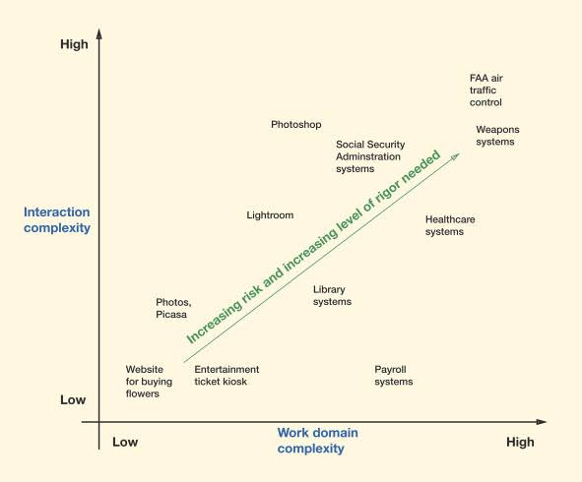Low interaction complexity usually corresponds to systems that support smaller tasks that are generally easy to do, such as ordering flowers from a website.
* High interaction complexity is usually associated with larger and more difficult tasks, often requiring special skills or training, such as manipulating a color image with Adobe Photoshop

**7. What is Scope of Delivery?**

* Our use of the term “scope” refers to how the target system or product is “chunked” in each iteration or sprint for delivery for agile implementation.
* In a large scope, chunks are composed of multiple features or even large portions of the system.
* In a **small** **scope**, synonymous with agility, chunks are usually comprised of one feature at a time.
* **Large** **scope**: Design the whole house first and build it all before delivering it to the client including Electrification, Plumbing, Interior walls.
* **Small** **scope**: Design one room (for example, the kitchen) first, build it, and deliver it to the client, and follow up with another room, say the living room, and so on, in a series of “increments” until the whole house is completed.

**8. Mentions Challenges in Building systems.**

Change Happens During a Project:

Evolution of project requirements and parameters

* Requirements (statement of system needs).
* Product concept, vision.
* System architecture.
* Design ideas.
* Available technology

External changes

* Technology available at the time.
* Client’s directions and focus (possibly due to shifting organizational goals or market factors)

Two Views of These Changes

* Reality
* Designer’s understanding of these changes

The Gap Between Views

Responding to Change

Closing the Gap

True Usage is the Only Ascertainer of Requirements

Communicating Feedback About Requirements

* Communication problems on the user’s side
* Are not necessarily knowledgeable about technology and the overall system.
* Might have trouble formulating problems in their own minds (e.g., inability to abstract from problem instance details).
* Might lack the ability to articulate feedback about requirements.
* Might give feedback based on what they think they want.
* Have biases about certain aspects of the system.

**9. Draw and explain the funnel model of Agile UX**

The funnel model of agile UX, a way of envisioning UX design activities before syncing with agile SE sprints (for overall conceptual design in the early funnel) and after syncing with SE (for individual feature design in the late funnel).

**Scope in the funnel model**

* The vertical dimension of the diagram is scope. A larger funnel diameter (taller in the vertical dimension of Fig.) at any point on the funnel represents a larger scope there. And a small diameter means smaller scope at that point.

Fig. shows a typical case where the scope of the early funnel is larger than the scope of the late funnel.

**Speed and rigor in the funnel model**

* The horizontal dimension of the diagram is time, representing how long activities in the funnel take to play out.
* The stripes or segments depicted on the funnel visually represent iterations or sprints and the length of a segment represents the duration in time of that sprint and, by implication, the speed of methods and techniques that have to be used in a given iteration.
* Longer sprints usually correspond with higher rigor, which will need methods and techniques that are more thorough and meticulous for that iteration.

**Late Funnel Activities**

* The late funnel, or the “spout” on the right side of Fig., is where the agile UX and agile SE processes are working in synchronism.
* Here, the goal of both the UX and SE sides is typically described in terms of small chunks within a small scope (represented by the small diameter of the funnel spout) delivered within a relatively small time increment (narrow sprint duration stripe).

**Early Funnel Activities**

* Before we can do the small-scope incremental releases in the synchronized late-funnel flow of Fig., we have to start with a full-scope analysis and design up front in the early funnel.
* UX must start the design for a new system with a top-down view to understand the ecology and needs and to establish a conceptual design.
* This is a requirement for UX because of the nature of UX design. Unlike code that is invisible to the user, UX design is not. Code is malleable in that it can be structured and refactored in every release. Redoing the design of the UI like that will drive the users crazy.

This upfront UX activity, the solution to the second problem described in Section, which is sometimes called “sprint 0” because it precedes the first sprint in the late funnel, is to establish:

* An overview, a skeleton on which to put the features.
* A solid coherent conceptual design to guide the design for the features.
* An initial top-down design.

The funnel model of agile UX, shown in Fig, has two major parts: the early funnel on the left and the late funnel on the right.

**Assignment – 4**

**1. Explain Bottom-up Design approach**

* Bottom-up design is an approach to design that starts with the details known about the work domain, work practice, and how a product or system is being used and will be used. The design is then built up in a way that will support this known usage behavior.
* This bottom-up approach is predominantly a translation exercise done through a series of transformations on a path from work activity notes to models to UX requirements to design.
* The premise is that these requirements, if met in the new design solution, will solve the problems of the users in this work practice, help users be more productive, and satisfy business mandates
* In bottom-up design, usage research is to analyze and model the existing work practice to improve it.



In a bottom-up approach, we would conduct usage research studies of voting with election booths to understand the current voting work practice in Virginia. We create work activity affinity diagrams, flow models, and other models to describe:

* Prevoting preparation:
* How citizens register to vote.
* How they find the nearest voting stations.
* What they need when they show up at the voting stations.
* The onsite configuration:
* How voting booths are set up.
* How voters interact with the booths.
* The workflow of voting:
* Voter identification.
* Checking voters off the rolls.
* Guiding voters to the appropriate booths.
* Postvoting follow-up:
* Counting ballots.
* Combining tallies from all sites.
* Announcing winners.

**2. Explain Top-Down Design approach**

* In top-down UX design creation, the goal is to create the best design solution that enhances and supports the fundamental nature of work irrespective of current practices, preferences, traditions, or constraints.
* The primary driver in the top-down approach to design is the designer and the designer’s knowledge, skills, experience, and intuition.
* In top-down design, usage research is to formulate and understand the abstract conceptualization of underlying essentials of the work.

The top-down approach. Using a top-down approach based on an abstract work activity, we would:

* Focus on designing the best way to get eligible users to elect someone from a list of candidates.
* Bring into consideration all ways, including voting booths, to make this work happen.
* Consider a smartphone app or a website to vote from the comfort of the home?
* Or a 1-800 number where citizens can call and cast their votes?
* An Internet-connected device in the home that could be used for voting and that could also be used for other expressions of opinions, including petitions, surveys, and likes or dislikes of products.
* Allow for possibilities where citizens can vote over a period of time leading up to a deadline.
* Even provides for flexibility, allowing citizens to change their vote after it is cast up to the deadline—something mail-in ballots do not allow:
* Perhaps new information about a candidate was unearthed in the interim.
* Emphasize designing for a very different envisioned ecology (in fact, defining the ecology is part of the design).
* ****Design for the interaction (workflows, etc.), information needs (for example, full display of candidates and their party affiliations, which offices a given voter can cast ballots for, full description of each side of all issues and proposals up for a vote) and emotional needs after ecological design is completed.

**Characteristics of Top-Down Design**

* Top-down design can be perceived as visionary.
* Top-down design is heavily driven by domain knowledge.
* Being a potential user in the domain is good for a designer.

**3. Differentiate Bottom-up and Top-Down approaches**

|  |  |  |
| --- | --- | --- |
| **No**. | **Top-Down Approach** | **Bottom-Up Approach** |
| 1 | In this approach we focus on breaking up the problem into smaller parts. | In bottom up approach, we solve smaller problems and integrate it as whole and complete the solution. |
| 2 | Mainly used by Structured Programming language such as COBOL, Fortran, c, etc. | Mainly used by Object Oriented Programming language such as C++, C#, Python. |
| 3 | Each part is programmed separately therefore contain redundancy. | Redundancy is minimized by using data encapsulation and data hiding. |
| 4 | In this the communication is less among modules. | In this module must have communication. |
| 5 | It is used in debugging, module documentation, etc. | It is basically used in testing. |
| 6 | In top down approach, decomposition takes place. | In bottom up approach composition takes place. |
| 7 | In this top function of system might be hard to identify. | In this sometimes we cannot build a program from the piece we have started. |
| 8 | In this implementation details may differ. | This is not natural for people to assemble. |

**4. Explain overview of Generative Design**

* Designers perform generative design, an approach to design creation involving ideation, sketching, and critiquing in a tightly coupled, but not necessarily structured, iterative loop for exploring a design idea,
* The role of prototype is played by sketches, and the role of evaluation is carried out by discussion and critiquing.
* The output of generative design is a set of alternatives for conceptual designs and other capabilities or patterns for each level of the needs pyramid, mostly in the form of annotated rough sketches or storyboards.



**5. List and explain Generative Design activities in brief.**

Generative Design activities are listed below:

* **Ideation**: The activity where ideas are spawned. A cognitive technique to create varying and innovative design possibilities.

Ideation is the process of creating various and innovative proposals for ecological, interaction, and emotional designs. This is a hugely creative and fun phase

* **Sketching**: An externalization activity that captures those ideas in concrete representations. Sketching is the rapid creation of freehand drawings expressing preliminary design ideas, focusing on concepts rather than details. Sketching is the rapid creation of freehand drawings expressing preliminary design ideas, focusing on concepts rather than details.
* **Critiquing**: An analysis activity to evaluate the emergent design ideas for tradeoffs
* **Refining**: An activity (usually iterative) where ideas are adopted, modified, or discarded.

**6. What is Ideations?**

* Ideation is the process of creating various and innovative proposals for ecological, interaction, and emotional designs. This is a hugely creative and fun phase
* Diversity in the design team helps with ideation because it brings varied perspectives.
* Ideation is the time to get clients and users to participate. The activity where ideas are spawned. A cognitive technique to create varying and innovative design possibilities.
* Ideation is the most important generative aspect of design; it is the leading edge of the act of creation. Ideation is the process of creating various and innovative proposals for ecological, interaction, and emotional designs. This is a hugely creative and fun phase.

**7. What is Sketching?**

* Sketching is the rapid creation of freehand drawings expressing preliminary design ideas, focusing on concepts rather than details.
* The idea of sketching as an indispensable part of design goes back at least to the middle Ages. Consider da Vinci and his famous sketchbooks. Nilsson and Ottersten (1998) describe sketching as an essential visual language for brainstorming and discussion.

**Characteristics of sketching**

* Everyone can sketch; you do not have to be artistic.
* Most ideas are conveyed more effectively with a sketch than with words.
* Sketches are quick and inexpensive to create; they do not inhibit early exploration.
* Sketches are disposable; there is no real investment in the sketch itself.
* Sketches are timely; they can be made just in time, done in the moment, provided when needed.
* Sketches should be plentiful; entertain a large number of ideas and make multiple sketches of each idea.
* Textual annotations play an essential support role, explaining what is going on in each part of the sketch and how.



Fig. A sketch to think about design (photo courtesy of Akshay Sharma, of the Virginia Tech Department of Industrial Design).

**8. List advantages of Prototyping**

* Provide a platform to support UX evaluation with users.
* Offer concrete baseline for communication between users and designers.
* Provide a conversational “prop” to support communication of concepts not easily conveyed verbally.
* Allow users to “take the design for a spin” (who would buy a car without taking it for a test drive or buy a stereo system without first listening to it?).
* Give project visibility and buy-in within customer and developer organizations.
* Encourage early user participation and involvement.
* Give the impression that design is easy to change because a prototype is obviously not finished.
* Afford designers immediate observation of user performance and consequences of design decisions.
* Help sell management on an idea for new product.
* Help affect a paradigm shift from an existing system to a new system

**9. Explain Depth and Breadth of prototyping with a appropriate diagram.**

* The idea behind prototypes is to provide fast and easily changed early views of an envisioned UX design.
* Because it must be quickly and easily changed, a prototype is a design representation that is in some way(s) less than a full implementation.
* The choices for your approach to prototyping are about how to make it less. One way you can make it less is by focusing on just the breadth or just the depth of the system.
* When you slice the features and functionality of a system by breadth, you get a horizontal prototype.
* And when you slice by depth, you get a vertical prototype



Fig: Horizontal and vertical prototyping concepts, adapted from Nielsen (1993), with permission.

**Horizontal Prototypes**

* A horizontal prototype is very broad in the features it incorporates, but offers less depth in its coverage of how that functionality works.
* It provides an overview on which you can base a top-down approach.
* Effective in demonstrating the product concept and for conveying an early product overview to managers, customers, and users.
* Horizontal prototypes usually do not support complete workflows, and user experience evaluation with this kind of prototype is generally less realistic.
* Prototyping in the early funnel tends to be horizontal in nature.

**Vertical Prototypes**

* A vertical prototype contains more depth of detail for some functionality, but only for a narrow selection of features.
* A vertical prototype allows testing a limited range of features but those functions that are included are evolved in enough detail to support realistic user experience evaluation.
* Often the functionality of a vertical prototype can include a stub for or a connection to an actual working backend database.
* Is ideal, when you need to represent completely the details of an isolated part of an individual interaction workflow in order to understand how those details play out in actual usage.
* They are most commonly used in the late funnel part of the process.

**Local Prototypes**

* A prototype that is narrow in both dimensions, limiting its focus to a localized interaction design issue.
* Is used to evaluate design alternatives for particular isolated interaction details, such as one dialogue box, the appearance of an icon, the wording of a message, or the behavior of an individual interaction object.
* A local prototype is the solution for those times when your design team encounters an impasse in design discussions where, after a while, there is no agreement and people are starting to repeat themselves.

**10. What is T Prototyping?**

* A “T” prototype combines advantages of both the horizontal and vertical prototypes, offering a good compromise for design evaluation. Much of the feature breadth is realized at a shallow level (the top of the T), but a few parts are done in depth (the vertical part of the T).
* It is recommending the T prototype because it provides a nice balance between the two extremes, giving you some advantages of each.
* Once you have established a system overview in your horizontal prototype, as a practical matter the T prototype is the next step toward achieving some depth.
* The horizontal foundation supports evolving vertical growth across the whole prototype.

**11. Explain Wireframe Prototyping.**

* A wireframe is a static, low-fidelity representation of your product, and in the world of web and mobile design, a basic guideline of your website or app – the skeletal framework – for both designers and developers to follow.
* For instance, developers tend to use wireframes to better understand the core functionality of a website or app, whereas designers may use them to show the navigation flow between site screens.
* A wireframe is a sketch, image, or prototype of a single interaction page or screen (in the broadest sense of “screen”).
* Wireframes are described as two-dimensional sketches or drawings consisting of lines, arcs, and vertices (thus the name wireframe), plus some text for labels, representing the layout of an interaction design for a page or screen.
* These wireframes are best generated with a software tool (such as Sketch).
* Wireframe Design Elements
* Low-fidelity wireframes usually do not have graphical design elements such as images or specific colors or typography.

**Figure: Generic Wire flow diagram**

Typical elements represented in a wireframe can include:

* Header.
* Footer.
* Content areas.
* Labeling.
* Menus.
* Tabs (possibly with drop-downs).
* Buttons.
* Icons.
* Pop-ups.
* Messages.
* Navigation bar, navigation links.
* Placeholders for logo and branding images.
* Search field.

**The benefits of wireframing**

* Wireframes are fast, cheap and easy to create, and quick to be approved. You can therefore, properly plan the basics before moving forward, avoiding rework.
* Starting off with paper wireframes, your initial sketches will be low fidelity, low cost, and low energy.
* Wireframes are easy for stakeholders to visualize and digest from early on without getting bogged down in the details.

**Assignment - 5**

**1. Explain UX Evaluation Technique in detail.**

* **Competitor Analysis:** Performing an audit/review of competing websites and apps; conducting user testing of competing sites; writing a report that summarizes the competitive landscape.
* **Analytics Review:** Analyzing web or mobile usage data, and making subsequent recommendations.
* **Stakeholder Interviews:** Conversations with the key contacts in the client organization funding, selling, or driving the product.
* **Contextual** **Enquiry**: Interviewing users in the location that they use the website/app, to understand their tasks and challenges.
* **Surveys**: Crafting an online survey, primarily to solicit feedback from current (or potential) users.
* **Content** **Audit**: Reviewing and cataloguing a client’s existing repository of content.
* **Diary** **Study**: Asking users to record their experiences and thoughts about a product or task in a journal over a set period of time.
* **User** **Interviews**: User interviews are a key activity for understanding the tasks and motivations of the user group for whom you are designing. Interviews may be formally scheduled, or just informal chats (for instance, in a suitable location that your target demographic are present).
* **Heuristic** **Review**: Evaluating a website or app and documenting usability flaws and other areas for improvement.
* **User** **Testing**: Sitting users in front of your website or app and asking them to perform tasks, and to think out loud while doing so.
* **Unmoderated** **Remote** **Usability** **Test**: URUT is similar to in-person usability testing however participants complete tasks in their own environment without a facilitator present. The tasks are pre-determined and are presented to the participant via an online testing platform.
* **Use** **Cases**: A use case is a list of steps that define the interactions between a user and a system. Use cases, especially when used as requirements for software development, are often constructed in UML, with defined actors and roles.
* **Storyboards**: A storyboard is a tool inspired by the filmmaking industry, where a visual sequence of events is used to capture a user’s interactions with a product. Depending on the audience, it may be an extremely rough sketch, purely for crystallizing your own ideas.
* **Affinity Diagramming**: A business technique for identifying and grouping patterns within unrelated data.
* **Personas**: A persona is a fictitious identity that reflects one of the user groups for who you are designing.
* **Scenarios:** A scenario is a narrative describing a day in the life of  one of your personas, and probably includes how your website or app fits into their lives.
* **Collaborative Design**: Inviting input from users, stakeholders, and other project members.
* **Workflow Diagram:** A workflow diagram (or activity diagram) is a graphical representation of activities and actions conducted by users of a system.
* **Sitemap:** A sitemap is a complete list of all pages available on a website.
* **Wireframe**: A wireframe is a rough guide for the layout of a website or app. A prototype is similar in that while far from being a polished product in terms of visuals or functionality, it gives an indication of the direction that the product is heading. A Mockups a is the term I use for wireframes that have been created in high fidelity, but for some people these three terms are interchangeable.
* **Card Sorting:** Card sorting is a technique where users are asked to generate a folksonomy, or information hierarchy, which can then form the basis of an information architecture or website navigation menu.
* **Competitive Analysis:** An activity that involves listing direct rivals and evaluating their strengths, weaknesses and activity in the marketplace in comparison to your own.
* **Decision Matrix:** A table or spreadsheet that lists various options and then tallies scores for each against range of weighted factors and characteristics. The highest scoring option indicates the best choice.
* **SWOT Analysis:** A structured planning method for evaluating helpful and harmful elements internally and externally to a venture, using sections for Strengths, Weaknesses, Opportunities and Threats.
* **User Stories:** An informal, natural-language description of features in a software system, often captured on an index card or sticky note, and generally written by (or from the perspective of) an end user or customer.

**2. Explain UX Methods in detail.**

* An individual method can collect data about a set of specific constructs of user experience. For instance, usability testing is used to collect data about usability construct.
* UXA methods can be classified in three categories: implicit, explicit and creative methods.

**Implicit method**: Implicit methods of UX research focus not just only on what the users say, but also on what the user cannot express verbally. Many available tools can assist in the implicit evaluation, in particular to gather implicit or objective data. When available, UX researchers utilize state of the art equipment to uncover all aspects of the experience.

Examples of implicit evaluation methods and tools:

* Eye tracking
* Attention tracking
* User tracking

**Explicit method**: Explicit methods of UX research explore what the user is consciously aware of getting them to reflect on their own feelings or thoughts, and gather their views and opinions. An important aspect of explicit methods includes usability testing and emotion evaluation.

**Surveys**: Crafting an online survey, primarily to solicit feedback from current (or potential) users.

**SWOT Analysis:** A structured planning method for evaluating helpful and harmful elements internally and externally to a venture, using sections for Strengths, Weaknesses, Opportunities and Threats.

**Card Sorting:** Card sorting is a technique where users are asked to generate a folksonomy, or information hierarchy, which can then form the basis of an information architecture or website navigation menu.

**Personas**: A persona is a fictitious identity that reflects one of the user groups for who you are designing.

**Stakeholder Interviews:** Conversations with the key contacts in the client organization funding, selling, or driving the product.

**Empirical UX Evaluation Methods:** Empirical methods, by definition, depend on data observed in the performance of real user participants and data coming directly from user participants.

**Analytic UX Evaluation Methods:** Analytic methods are based on examining inherent attributes of the design rather than seeing the design in use.

**3. Differentiate UX Methods and UX Techniques.**

* A method is a way one can carry out the whole or part of a given lifecycle activity or sub activity.
* A UX technique is a specific detailed practice you can use to perform a step within an activity, sub activity, or method.
* Early method and technique choices constrain later ones. Earlier choices of methods and techniques can constrain later choices by suggesting, eliminating, or dictating appropriate methods and techniques for subsequent choices.
* For example, methods and techniques used for data analysis in a given situation will depend on what kind of data you have, and how the data were collected.
* There is not a clear-cut definition of the difference between a method and a technique in our practice, with the main difference being level.
* An evaluation method is a high-level overall way of doing UX evaluation and a technique is usually a lower-level way of doing specific steps within a method.

**4. Explain Empirical UX evaluation Goals, metrics and targets.**

UX goals, metrics, and targets help build scaffolding to support planning for evaluation that will successfully reveal problems with user performance and emotional satisfaction.

**UX Evaluation Goals:**

* UX goals are high-level objectives for a UX design, stated in terms of user experience objectives. UX goals can be driven by business goals and reflect real use of a product and identify what is important to an organization, its customers, and its users.
* They are expressed as desired effects to be experienced in usage by users of features in the design and they translate into a set of UX measures to be assessed in evaluation.
* You can extract UX goals from user concerns captured in work activity notes, the flow model, social models, and work objectives, some of which will be market driven, reflecting competitive imperatives for the product.
* User experience goals can be stated for all users in general, in terms of a specific work role or user class, or for specific kinds of tasks.
* Examples of user experience goals include ease of use for all users, ease of remembering for intermittent users, power performance for experts, avoiding errors for safety-critical systems, high customer satisfaction, walk-up-and-use learnability for new users, and so on.

**Identify UX Evaluation Goals for Your System**

* **Goal**: A little experience in stating user experience goals.
* **Activities**: Review the work activity affinity diagram (WAAD) and user concerns in the social model for the system of your choice, noting user or customer concerns relating to UX goals.
* **Deliverables**: A short list of UX goals for one user class of the system of your choice.
* **Schedule**: A half hour or so (it should be easy by now).

**UX Metrics:**

* A UX metric describes the kind of value to be obtained for a UX measure. It states what is being measured. There can be more than one metric for a given measure.
* As an example, from the software engineering world, software complexity is a measure; one metric for the software complexity measure (one way to obtain values for the measure) is “counting lines of code.”
* Probably the most common UX metrics are objective, performance-oriented, and taken while the participant is doing a benchmark task. Other UX metrics can be subjective, based on a rating or score computed from questionnaire results.

We hope you will explore many other possibilities for UX metrics, extending beyond what we have mentioned here, including:

* Percentage of task completed in a given time.
* Ratio of successes to failures.
* Time spent moving cursor (would have to be measured using software instrumentation, but would give information about the efficiency of such physical actions, necessary for some specialized applications).
* For visibility and other issues, fixations on the screen, cognitive load as indicated by correlation to pupil diameter, and so on using eye tracking.

**5. Explain Analytic UX Evaluation with different Data Collection Methods and Techniques.**

* **Qualitative Data Collection Techniques:**
* Qualitative data collection techniques are used to capture data for UX problem identification. Critical incident identification, think aloud, and codiscovery, described next, are among the most popular qualitative data collection techniques.
* **Objective data User performance measures:**
* Some quantitative data collection techniques employ user performance measures taken during empirical UX testing with user participants. Users perform benchmark tasks and UX evaluators take objective measures, such as the time to complete a task.
* **Critical incident identification:**
* Critical incident identification is a qualitative UX data collection technique that involves the UX team observing user participants performing tasks and detecting “critical incidents,” or occurrences where users encounter UX problems.
* **Users think-aloud techniques:**
* The think-aloud technique is usually applied together with critical incident identification as a second way of spotting UX problems during user task performance. In this technique, users are encouraged to express their thoughts verbally as they perform tasks and exercise the UX design, thus revealing otherwise possible hidden qualitative data about UX problems. The think-aloud technique is perhaps the most useful of all UX evaluation techniques as it gets at the user’s state of mind precisely at the time of use.
* **Co discovery:**
* You can use two or more participants in a team approach to the think-aloud technique (O’Malley, Draper, & Riley, 1984), an approach that Kennedy (1989) called “co discovery”. Multiple participants sometimes offer the natural ease of talking in conversation with another person (Wildman, 1995), leading to data from multiple viewpoints.
* **Alpha and Beta Testing and Field Surveys:**
* Alpha and beta testing are useful post deployment evaluation methods. After almost all development is complete, manufacturers of software applications sometimes send out alpha and beta (pre-release) versions of the application software to select users, experts, customers, and professional reviewers as a preview.
* You don’t get the kind of detailed UX problem data you get from a mainstream formative evaluation process.
* It is usually too late to change the design in any significant way if problems are identified.
* **Criticism of Analytic Methods**:
* Analytic UX evaluation methods, including most inspection methods, have been criticized In HCI literature of the past. Sometimes disparagingly called “discount methods,” analytic methods have been criticized for not being thorough and for being unscientific.
* **Focus Groups**:
* Focus groups, composed of a moderator and, say, a half-dozen other participants, are an analytic method for (in our practice) early evaluation of UX designs.
* As Martin and Hannington (2012) say, “The power of focus groups lies in the group dynamic that it creates.”
* Group members share opinions and collaboratively discuss the pros and cons as peers. As the group members describe their experiences and feelings, they will tell stories and use metaphors and analogies.
* At the end of a session, the moderator leads the group in creating a summary of the discussion.
* **Expert UX Inspection**:
* A UX inspection is an analytic evaluation method in that it involves evaluating by looking at and trying out the design yourself as a UX expert instead of having participants’ exercises it while you observe.
* The evaluator is both participant surrogate and observer.

Storyboard

**Assignment - 6**

**1. Explain Challenges in agile SE from the UX perspective.**

* Agile methods make SE practitioners feel productive and in control because they and their customers, and not some overarching design, drive the process.
* These methods are inexpensive, fast, and lightweight, with early deliverables. The pair programming aspect also seems to produce high-reliability code with fewer bugs.
* Nonetheless, agile SE methods are programming methods developed by programmers for programmers, and they pose some challenges from the UX perspective.
* Because big design upfront is shunned, there is no upfront analysis to glean general concepts of the system and associated work practice.
* The one customer representative on the team is not required even to be a real user and can’t be expected to represent all viewpoints, needs and requirements, usage issues, or usage context.
* There may be no real user data at all upfront, and coding will end up being “based only on assumptions about user needs” (Memmel, Gundelsweiler, and Reiterer, 2007, p. 169).
* There is no identification of user tasks and no process for identifying user interaction or information needs.
* Beyer, Holtzblatt, and Baker (2004) echo this criticism of using a customer representative as the only application domain expert.
* As they point out, under their Axiom 2, “Make the user the expert,” many customer representatives are not also users and, therefore, can’t necessarily speak for the work practice of others.
* Beyond these predesign drawbacks, the agile SE method does not involve design, so, there is no room in the process for design ideation.

**2. Explain synthesized approach to integrating agile UX.**

* Most of the early literature about incorporating UX into the agile SE development process is based on either adjusting UX design methods to somehow keep pace with existing agile SE methods or trying to do just selected parts of UX design processes in the presence of an essentially inflexible agile SE method.
* While it is possible that XP, for example, and some abbreviated UX design techniques can coexist and work together, in these add-on approaches, the two parts are not really combined (McInerney and Maurer, 2005; Patton, 2002, 2008).
* This creates a coping scenario on theUX side, as UX practitioners attempt to live with the constraints while trying to ply their own processes within an overall development environment driven solely by the agile SE method.
* Here, we have tried to synthesize an approach to allow our agile UX process to mesh with an agile SE environment without compromising on essential UX needs.
* We especially acknowledge the influence of Constantine and Lockwood (2003), Beyer et al. (2004), Meads (2010), and Lynn Miller (2010).

Here are the ways to synthesized approach integrating agile UX listed below:

* Integrating UX into Planning
* Small upfront analysis and design
* UX role helps customer write user stories
* The truth about user stories
* UX role helps customer prioritize user stories
* Integrating UX into Sprints
* Synchronizing the Two Agile Workflows
* Dove-tailed work activities
* The value of early delivery
* Continuous delivery
* The importance of regression testing
* Planning across iterations
* Communication during synchronization

**3. Explain how can we Integrate UX into planning?**

* Fig. B shows a scheme for integrating the UX role into the planning box of Fig. A.
* Planning in Fig. B features small upfront analysis and design by the UX designer, customer, and users, in the left-most box, producing a broad (if partial) understanding of the work domain, work practice, and conceptual model (next to left-most box).
* This upfront UX activity occurs in the early agile UX funnel.



**Figure A**



**Figure B**

**Small upfront analysis and design**

* The small upfront analysis and design, in the left-most box of Fig. B, is our way of including an initial abbreviated form of usage research and design that involves the customer and users.
* This is exactly what happens in the early agile UX funnel. And much of the “design” in the early funnel small upfront analysis and design is conceptual design to establish the high-level consistency overview.
* Also, in planning, the UX person also assists the customer in other responsibilities, such as writing and prioritizing stories.
* These stories are now called user stories rather than customer stories because their substance came from users in the upfront analysis.

Goals of the small upfront analysis and design in the early agile UX funnel include:

* Understand the users’ work and its context.
* Identify key work roles, work activities, and user tasks.
* Model workflow and activities in the existing enterprise and system.
* Forge an initial high-level conceptual design.
* Identify inputs for selected user stories that reflect user needs in the context of their work practice.

**UX role helps customer write user stories**

* In the third box from the left in Fig. B, the UX person helps the customer write user stories. As we said earlier, the UX person usually takes charge of user story writing to ensure completeness, appropriate scope, consistency, and cohesion.
* Because UX team members, customers, and users participate in the early agile UX funnel small upfront analysis and design, user story writing will be easier, faster, and more representative of real user needs. The UX role influences the customer toward creating stories based on workflows revealed in the agile usage research part of small upfront analysis and design.

**The truth about user stories**

* As we explained, you can’t depend on stories written by just users to be accurate, complete, or comprehensive.
* So, in real projects, UX analysts and designers take inputs from users collected in usage research and write small-scope user capability requirements as user stories, as though users had expressed them, so the whole collection has a uniform format.
* This is one important way process variations exist in practice.

**UX role helps customer prioritize user stories**

* By helping the customer representative prioritize the user stories, the UX person can keep an eye on the overarching vision of user experience and a cohesive conceptual design, thereby steering the result toward an effective set of stories for iteration.

**4. Explain how to Integrate UX into sprints?**

* In Fig. B, we show UX counterpart activities occurring in the late funnel during an agile SE sprint of Fig. A.



**Figure A**



**Figure B**

* While the SE people are doing a sprint, the UX person and customer perform their own version of a sprint, which is shown in Fig. B.
* They begin by picking a story or picking a feature with a set of related user stories. With the conceptual design in mind, the UX designers start ideation an sketching of an interaction design to support the functionality of the user story.
* Initial static wireframe prototypes are used as sketches of interaction designs, leading to “interactive” click-through wireframe prototypes to demonstrate navigation within interaction sequences. Design reviews, design walk-throughs, plus iterative design fixes.
* At this small scope, the tightly-coupled design creation-prototyping-evaluation cycle will often start with frequent multiple static wireframe sketches.
* These sketches are iteratively reviewed within the UX team for ideation in task-level design creation.
* This early design ideation and sketching can also involve brief focused returns to usage research to fill gaps and answer questions about the feature.
* When the UX team is satisfied they have their best initial design, it is demonstrated in the form of a click-through wireframe prototype in a walkthrough review with all stakeholders, including client/customers and users.
* The typical result is possibly multiple rounds of feedback, refinement, and further evaluation.
* Then, the same kind of walk-through evaluation is done with SE developers, to get feedback on feasibility, consistency, platform issues, etc.
* This leads to possibly multiple rounds of fixing and refining, leading to a handoff to developers for implementation. By this time, UX designers and software developers should be on the same page about the feature.
* After implementation, the UX designer should check the result against the UX designs for fidelity of implementation. Then, the whole team should submit the working feature to the customer for acceptance review.